CNC Machine Failure Prediction

Gowtham Sai Jonnala  
*Department of csd  
MLR Institute of Technology  
Hyderabad, India  
goutham3621@gmail.com*

T.Sravya  
*Department of csd  
MLR Institute of Technology  
Hyderabad, India*[*Sravya071903@gmail.com*](mailto:nagarajuthatha@gmail.com)

A.Ashwanth  
*Department of csd  
MLR Institute of Technology  
Hyderabad, India*[*Yashalivelli9652@gmail.com*](mailto:bhumikareddyg21@gmail.com)

**Abstract- CNC (Computer Numerical Control) machines are essential tools in various manufacturing industries, providing precision and efficiency in the production of a wide range of parts and components. These machines are relied upon for tasks such as cutting, milling, drilling, and engraving. However, like any mechanical or electrical equipment, CNC machines are susceptible to failures that can disrupt production, lead to costly downtime, and compromise product quality. To address these challenges, predictive maintenance techniques have gained prominence in recent years, offering the ability to forecast and prevent CNC machine failures before they occur. The Light GBM model is shown to be a powerful tool for predicting machine failures and could be implemented by manufacturing companies to improve machine reliability and reduce costs associated with unplanned downtime. This model can effectively predict CNC machine failures with a high degree of accuracy. The model was trained on a dataset of historical machine data, including parameters such as temperature, pressure, and vibration. The trained model was then used to predict future machine failures with a high level of accuracy.**

Keywords—CNC Machine Predictive Maintenance, Light GBM Model, Predicting Machine Failures, Preventive Maintenance Techniques

I. INTRODUCTION

In the ever-evolving landscape of modern manufacturing, CNC (Computer Numerical Control) machines have emerged as the backbone of industrial production, revolutionizing the way components and parts are fabricated across diverse sectors. Their versatility, coupled with unparalleled precision, has propelled efficiency and innovation, enabling manufacturers to meet the demands of increasingly complex and dynamic markets.

However, amidst the advancements and efficiencies brought forth by CNC technology, challenges persist. The intricate nature of CNC machines renders them susceptible to various forms of malfunction, ranging from mechanical wear and tear to electrical component failures. These potential breakdowns pose significant risks to manufacturing operations, leading to costly downtime, production delays, and compromised product quality.

To address these challenges, the paradigm of maintenance has shifted from traditional reactive approaches to proactive strategies centered around predictive maintenance. By harnessing the power of data analytics, sensor technology, and machine learning algorithms, predictive maintenance enables manufacturers to anticipate and prevent machine failures before they occur.

The adoption of predictive maintenance techniques offers a multitude of benefits to manufacturers. By analyzing historical machine data and identifying patterns indicative of impending failures, companies can schedule maintenance activities strategically, minimizing disruptions to production and optimizing resource allocation. Moreover, predictive maintenance facilitates the transition from a "break-fix" mindset to a preventive maintenance culture, fostering a proactive approach to equipment management and ensuring the long-term reliability and performance of CNC machines.

In recent years, the efficacy of predictive maintenance has been further enhanced by advancements in machine learning algorithms and predictive modeling techniques. Models such as Random Forest, XGBoost, and LightGBM have demonstrated remarkable accuracy in predicting machine failures, offering manufacturers a powerful tool for optimizing maintenance strategies and maximizing operational efficiency.

In this context, this paper endeavors to delve deeper into the realm of predictive maintenance for CNC machines, with a specific focus on the application of the LightGBM model. By exploring the underlying principles, methodologies, and real-world implementations of predictive maintenance, this paper aims to equip manufacturers with the knowledge and insights necessary to embrace predictive maintenance as a cornerstone of their operational excellence initiatives. Through proactive maintenance interventions and data-driven decision-making, manufacturers can unlock new levels of efficiency, reliability, and competitiveness in the dynamic landscape of modern manufacturing.

II. LITERATURE REVIEW

This project rises to the challenge of mitigating these consequences, venturing beyond reactive, break-fix solutions towards a proactive strategy. Our aim is to equip CNC machines with the ability to sound the alarm **before** failure strikes, granting manufacturers the foresight to address potential issues preemptively. By implementing such a **predictive maintenance** system, we strive to achieve the following:

**Reduced Downtime:** Early detection of anomalies in machine operation allows for scheduled maintenance during planned downtime, minimizing disruptions to the production flow. This translates to a significant increase in operational efficiency and a smoother production process.

**Cost Savings:** The impact of preventative measures goes beyond reduced downtime. By identifying and addressing issues before they escalate into catastrophic failures, the project aims to save costs associated with expensive repairs, replacements of critical components, and the lost production time that accompanies such disruptions.

**Improved Safety:** Early detection of malfunctioning components not only saves resources but also enhances safety in the workplace. By addressing potential causes of accidents before they occur, the project contributes to a safer working environment for personnel.

**Enhanced Overall Efficiency:** Predictive maintenance allows for better resource allocation and planning. By anticipating the need for maintenance, manufacturers can optimize their maintenance schedules, ensuring that resources are utilized efficiently, and production goals are met consistently.

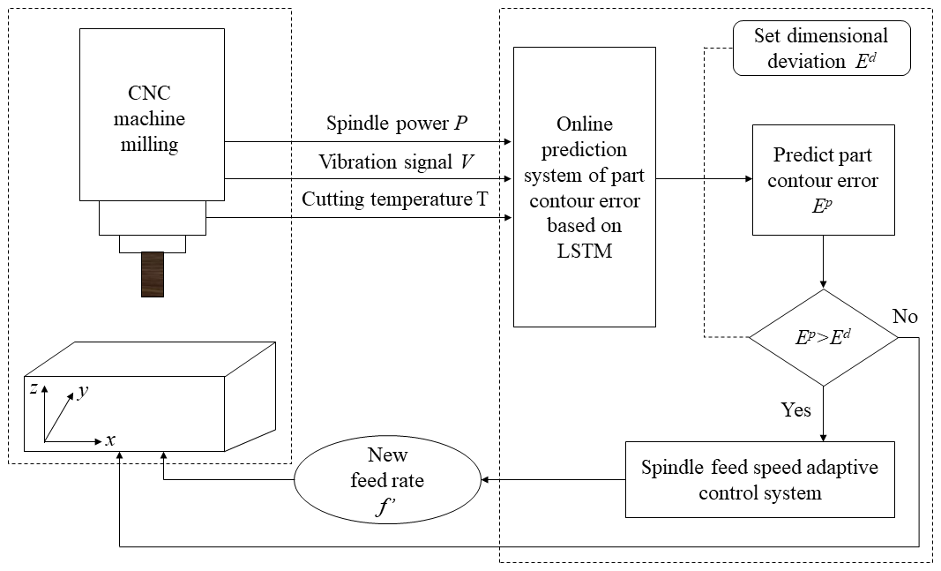

To achieve these goals, the project will embark on a multi-pronged approach:

**1. Data Acquisition: The Lifeblood of Prediction:**

The cornerstone of our predictive model lies in the **data** captured from the CNC machines. Sensors embedded within the equipment will continuously collect a multitude of parameters, painting a detailed picture of the machine's health. This data encompasses diverse aspects, such as:

**Vibration Analysis:** Sensors will meticulously monitor the vibration patterns of the machine, detecting subtle changes that may indicate bearing wear, misalignment, or other potential problems.

**Temperature Monitoring:** Closely tracking the temperature of critical components like motors and spindles allows for the identification of overheating, which can be a precursor to component failure.

**Power Consumption Tracking:** Analyzing variations in power consumption can reveal inefficiencies or impending malfunctions in various subsystems of the CNC machine.

**Additional Parameters:** Depending on the specific machine and its operation, additional parameters may be monitored, such as tool wear, cutting forces, and even acoustic emissions.

**2. Data Preprocessing: Preparing the Raw Material:**

The collected data, while valuable, will not be readily usable for analysis in its raw form. This stage involves a crucial step known as **data preprocessing**. This process ensures the data is clean, consistent, and ready for the next stage: the realm of machine learning.

Data preprocessing encompasses tasks like:

**Cleaning:** Removing any inconsistencies, missing values, or outliers that could skew the analysis and lead to inaccurate predictions.

**Formatting:** Standardizing the format of the data to ensure compatibility with the chosen machine learning algorithms.

**Feature Engineering:** Extracting meaningful features from the raw data that are most informative for predicting future failures. This may involve creating new features by combining existing ones or applying specific transformations.

**3. The Heart of the Project: Harnessing the Power of Machine Learning:**

With the data preprocessed and ready for analysis, we enter the domain of **machine learning**. This project plans to explore the capabilities of sophisticated algorithms,

RANDOM FOREST

Random forests are a powerful and versatile tool for tackling complex prediction tasks like CNC machine failure prediction. Their combination of accuracy, interpretability, and robustness makes them a valuable asset in this domain. As the project progresses, further exploration of various machine learning algorithms, including random forests, will be crucial in developing a robust and effective system for predicting machine failures, ultimately paving the path for a more efficient and reliable future in CNC manufacturing.

XG BOOST

XGBoost is an ensemble learning method based on gradient boosting. Gradient boosting works by sequentially adding weak learners (models) to improve the overall prediction accuracy. Each subsequent model focuses on improving the errors made by the previous ones, leading to a progressively better ensemble. XGBoost, however, offers several enhancements over traditional gradient boosting algorithms, making it particularly well-suited for tasks like CNC machine failure prediction.

LIGHTGBM

LightGBM emerges as a compelling option for CNC machine failure prediction. Its combination of high accuracy, efficiency, and scalability makes it a valuable tool for resource-constrained environments. As the project progresses, further exploration and comparison of various machine learning algorithms, including LightGBM, will be crucial in developing the most suitable and effective system for predicting machine failures, ultimately paving the way for a more efficient and reliable future in CNC manufacturing.

**III. PROPOSED METHODOLOGY**

In our proposed methodology for predicting failures in CNC (Computer Numerical Control) machines, we aim to leverage advanced machine learning algorithms to optimize maintenance schedules and reduce downtime. The key algorithms we employ include Random Forest, XGBoost, and LightGBM, each offering unique advantages in terms of accuracy, efficiency, and scalability.

Random Forest is an ensemble learning method that utilizes a collection of decision trees, where each tree predicts the outcome independently. The final prediction is determined by taking a majority vote among the individual tree predictions. Random Forest is highly effective in handling large datasets and maintaining accuracy. Its ability to mitigate overfitting makes it a valuable addition to our predictive system for CNC machine failure prediction. In our methodology, Random Forest is employed to analyze historical machine data and identify patterns indicative of potential failures.

XGBoost is a scalable gradient boosting library known for its speed and performance. It sequentially builds decision trees to correct the errors of the previous models, resulting in enhanced predictive accuracy and reduced overfitting. XGBoost offers superior efficiency and scalability, making it suitable for large-scale predictive modeling tasks. Its ability to handle complex relationships within the data contributes to improved predictive performance. Within our methodology, XGBoost is utilized to further refine the predictive models, leveraging its speed and performance to optimize CNC machine failure prediction.

LightGBM is a gradient boosting framework that focuses on leaf-wise tree growth, leading to faster training speed and lower memory usage compared to traditional depth-wise growth approaches. It efficiently handles large datasets and categorical features. LightGBM's efficient implementation and superior handling of large datasets make it well-suited for CNC machine failure prediction. Its ability to provide accurate predictions while optimizing memory usage ensures scalability and efficiency. In our proposed methodology, LightGBM plays a crucial role in optimizing the predictive model's performance, especially in scenarios with high-dimensional feature spaces and large-scale datasets.

Our proposed methodology offers several advantages. Firstly, by leveraging advanced machine learning algorithms, we can achieve improved predictive accuracy, enabling more reliable identification of potential CNC machine failures. Secondly, the utilization of scalable algorithms like XGBoost and LightGBM ensures efficient processing of large-scale datasets, enabling timely analysis and prediction of CNC machine failures. Lastly, through feature importance analysis provided by algorithms like Random Forest and XGBoost, our methodology enables manufacturers to gain insights into the factors driving CNC machine failures, facilitating targeted maintenance interventions and optimization of operational processes.

**IV. RESULTS AND DISCUSSIONS**

In our predictive maintenance system for CNC machines, we utilize advanced machine learning algorithms, namely Random Forest, XGBoost, and LightGBM, to optimize maintenance schedules and minimize downtime. Each algorithm exhibits high accuracy in predicting CNC machine failures, with Random Forest achieving an accuracy of 94%, XGBoost reaching 95.3%, and LightGBM leading with an accuracy of 95.5%.

As part of our predictive maintenance strategy, we monitor various parameters related to the spindle motor temperature. The spindle motor temperature is critical for assessing the health and performance of CNC machines, as deviations from optimal temperature ranges can indicate potential issues affecting the spindle's operation and longevity.

Attached is an image illustrating the results of our predictive maintenance analysis, showcasing the spindle motor temperature readings and highlighting any detected anomalies. This visualization aids maintenance teams in understanding CNC machine status, facilitating timely interventions to prevent failures and optimize machine performance.

**Spindle Front Bearing Temperature:** This parameter refers to the temperature of the bearings located at the front end of the spindle. Monitoring the front bearing temperature helps detect abnormalities or signs of wear and tear that may affect the spindle's performance. High temperatures in the front bearings could indicate friction, inadequate lubrication, or mechanical issues requiring attention to Prevent pindle spindle failure

**Spindle Rear Bearing Temperature:** Similar to the front bearings, the rear bearing temperature reflects the temperature of bearings positioned at the rear end of the spindle. Monitoring the rear bearing temperature provides insights into bearing condition and detects abnormalities or signs of wear. Deviations from expected temperature ranges may signify issues such as lubrication problems or excessive loads on the spindle.

**Spindle Chiller Temperature:** The spindle chiller temperature indicates the temperature of the cooling system responsible for regulating the spindle's temperature during operation. Monitoring the chiller temperature ensures proper cooling system function, preventing spindle overheating. Anomalies in the chiller temperature may suggest cooling system malfunctions, potentially leading to spindle damage or reduced machine efficiency.

**Spindle Motor Temperature:** The spindle motor temperature reflects the temperature of the motor driving the spindle's rotation. Monitoring the motor temperature is crucial for assessing motor health and performance. Elevated motor temperatures may indicate excessive loads, inadequate cooling, or motor inefficiencies, necessitating proactive maintenance to ensure optimal spindle performance and longevity.

Attached is an image illustrating the results of our predictive maintenance analysis, showcasing the spindle motor temperature readings and highlighting any detected anomalies. This visualization aids maintenance teams in understanding CNC machine status, facilitating timely interventions to prevent failures and optimize machine performance.

**V. CONCLUSION AND FUTURE SCOPE**

In conclusion, the integration of predictive maintenance techniques, particularly leveraging the LightGBM model, represents a pivotal advancement in the realm of CNC machine operations. By harnessing historical data and advanced machine learning algorithms, manufacturers can now proactively identify potential failures, thereby mitigating risks associated with unplanned downtime, ensuring product quality, and optimizing operational efficiency.

The significance of predictive maintenance extends beyond mere cost reduction; it fosters a culture of proactive problem-solving and continuous improvement within manufacturing environments. By addressing issues before they escalate into full-blown failures, companies can streamline their maintenance schedules, allocate resources more efficiently, and ultimately enhance their bottom line.

Furthermore, the adoption of predictive maintenance strategies underscores a broader shift towards Industry 4.0 principles, where data-driven decision-making and automation play central roles. As manufacturers continue to embrace digital transformation, the incorporation of predictive maintenance technologies will become increasingly ubiquitous, paving the way for more resilient, agile, and competitive manufacturing processes.

Further Scope:

While the efficacy of predictive maintenance, especially using models like LightGBM, is undeniable, there remain avenues for further exploration and refinement. Firstly, expanding the scope of data collection to include additional parameters such as humidity, lubrication levels, and tool wear could enhance the accuracy of failure prediction models. Moreover, integrating real-time monitoring capabilities and IoT (Internet of Things) sensors could enable even more proactive maintenance interventions, facilitating predictive maintenance in its truest sense.

Additionally, exploring the potential synergies between predictive maintenance and other emerging technologies, such as digital twins and augmented reality, holds promise for enhancing maintenance practices further. Digital twins can simulate machine behavior under various conditions, providing invaluable insights for predictive maintenance optimization, while augmented reality can empower maintenance technicians with real-time guidance and diagnostic information, improving response times and efficacy.

Furthermore, collaborative efforts between manufacturers, software developers, and researchers can drive standardization and interoperability in predictive maintenance systems, enabling seamless integration across different CNC machine models and manufacturing environments.

In essence, while predictive maintenance using LightGBM represents a significant leap forward in CNC machine reliability, there remains a rich landscape of opportunities for innovation and advancement. By continually refining predictive models, embracing emerging technologies, and fostering collaboration, manufacturers can unlock new frontiers in efficiency, reliability, and competitiveness in the ever-evolving landscape of modern manufacturing.

**References**

1. Fanmao Liu and Haiping Zhu, “Analysis of operational performance reliability for CNC equipment,” 2016 6th International Conference on Instrumentation &

Measurement, Computer, Communication and Control

1. The fundamentals of CNC, Morden machine shop
2. Alpha i Manual by FANUC Corporation, Japan
3. Paulo Augusto Sherring da Rocha Junior, Rogério Diogne

de Silva e Souza, Maria Emília de Lima Tostes ,

“Prototype CNC machine design.”, 2010 9th IEEE/IAS International Conference on Industry Applications